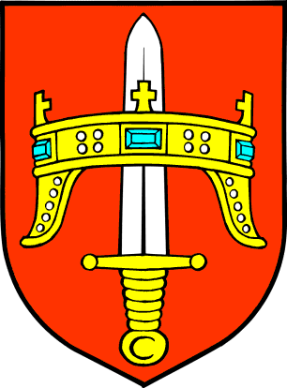
REPUBLIKA HRVATSKA
ŠIBENSKO-KNINSKA ŽUPANIJA
Trg Pavla Šubića I. br 2, 22 000 Šibenik
14.10.2014.

Our ref: HOLISTIC-FB3-05/14

Dear Sir/Madam,
INVITATION TO TENDER FOR Fire risk management expert services for Šibenik-Knin County area within HOLISTIC Project, Šibenik, Croatia
I am pleased to inform you that your firm / the consortium led by you is invited to take part in the competitive negotiated procedure for the above contract. The complete tender dossier is attached to this letter. It includes:
- Instructions to tenderers and contract notice
- Draft Contract Agreement and Special Conditions with annexes:
- General Conditions for service contracts
- Terms of Reference
- Organisation and Methodology (to be submitted by the tenderer using the template provided)
- Key experts (including templates for the summary list of key experts and their CVs)
- Budget (to be submitted by the tenderer as the Financial offer using the template provided)
- Forms and other supporting documents
- Other information:
- Administrative compliance grid
- Evaluation grid
- Tender submission form
For full details of the tendering procedures, please see the Practical Guide and its annexes, which may be downloaded from the following website: http://ec.europa.eu/europeaid/work/procedures/index_en.htm.
We look forward to receiving your tender before the deadline set in point 8 of the Instructions to tenderers. Please send it to the address given in point 8. If you decide not to submit a tender, we would be grateful if you could inform us in writing, indicating the reasons for your decision.

Yours sincerely,

Sanja Slavica Matešić, PhD

Project Manager

